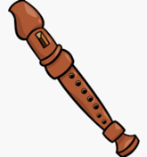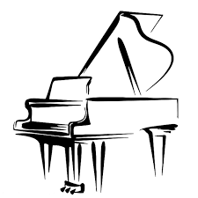♪♫ **Welcome to Music Room G06 at Samuel E. Shull Middle School!**

My name is Ms. DeWitt and I am very excited to be your child’s music teacher this year! I currently teach piano, recorders, chorus, and general music classes at Shull School. I am also the vocal director for our spring musical and chorus club.

Below are the rules and expectations for music class. In Google Classroom, students will gain access to daily music lessons, assignments, sheet music, and rubrics. Your child is to join his/her designated Music Google Classroom. It is my expectation that all students will try their personal best in class.

If you have any questions throughout the school year please contact me by e-mail at [ashldewitt@paps.net](mailto:ashldewitt@paps.net)

Thank you,

Ms. DeWitt

**M**ake good choices: students should be on time and prepared to participate in class on their laptops. Cell phones are not permitted during class time.

**U**se equipment properly:  the instruments and belongings in the classroom should be handled with care.

**S**peak and play when the time is right: We are patient and respectful while other students and teachers are speaking.

**I**nvolve yourself: all students will try their personal best in music class.

**C**ooperate with others: students are to be respectful to all of their classmates and teachers.

**District Grading Policy:**

60% Assessments

35% Classwork

5% Homework